**Lab#4 Implement OOP concepts with PHP for following program :**

**Use Student, Teacher and Subject Class to define relation between each of them. Display the details of te student studting a particular subject under a particular teacher, Use Constructor and Polymorphism**

|  |  |  |
| --- | --- | --- |
| **TAGS USED** | **ATTRIBUTES USED** | **DESCRIPTION** |
| <HTML> | -- | Write the description of HTML tags and attributes |
| <HEAD> | -- |  |
| <TITLE> | -- |  |
| <BODY> | BGCOLOR,TEXT, BACKGROUND |  |
| <H1>,<H2>,<H3>, <H4>,<H5>,<H6> | ALIGN |  |
| <FONT> | FACE,SIZE,COLOR |  |
| <P> (Paragraph) | -- |  |
| <U> (Underline) | -- |  |
| <HR> (Horizontal Rules) | WIDTH,COLOR,ALIGN |  |
| <BR> (Break Line) | -- |  |

**Final Outcome:**

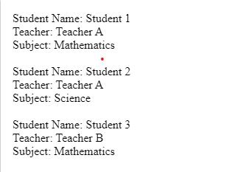

**Code Snippet:**

<?php

class Subject {

private $name;

public function __construct($name) {

$this->name = $name;

}

public function getName() {

return $this->name;

}

}

class Teacher {

private $name;

public function __construct($name) {

$this->name = $name;

}

public function getName() {

return $this->name;

}

}

class Student {

private $name;

private $teacher;

private $subject;

public function __construct($name, $teacher, $subject) {

$this->name = $name;

$this->teacher = $teacher;

$this->subject = $subject;

}

public function getName() {

return $this->name;

}

public function getTeacher() {

return $this->teacher->getName();

}

public function getSubject() {

return $this->subject->getName();

}

}

$mathSubject = new Subject("Mathematics");

$scienceSubject = new Subject("Science");

$teacherA = new Teacher("Teacher A");

$teacherB = new Teacher("Teacher B");

$student1 = new Student("Student 1", $teacherA, $mathSubject);

$student2 = new Student("Student 2", $teacherA, $scienceSubject);

$student3 = new Student("Student 3", $teacherB, $mathSubject);

echo "Student Name: " . $student1->getName() . "<br>";

echo "Teacher: " . $student1->getTeacher() . "<br>";

echo "Subject: " . $student1->getSubject() . "<br>";

echo "<br>";

echo "Student Name: " . $student2->getName() . "<br>";

echo "Teacher: " . $student2->getTeacher() . "<br>";

echo "Subject: " . $student2->getSubject() . "<br>";

echo "<br>";

echo "Student Name: " . $student3->getName() . "<br>";

echo "Teacher: " . $student3->getTeacher() . "<br>";

echo "Subject: " . $student3->getSubject() . "<br>";

?>